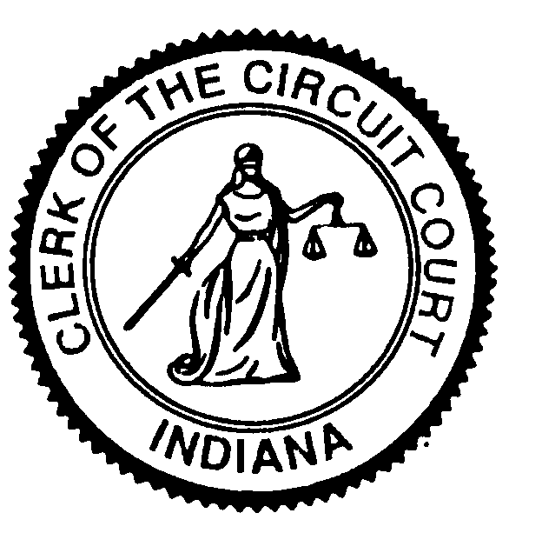
Kosciusko Circuit and Superior Courts
Melissa Boggs, Clerk
Ann Torpy, Chief Deputy
121 N Lake St, Room: D162, Warsaw, IN 46580
Telephone: 574-372-2331 Fax: 574-372-2338

Request for Copies of Marriage License or Marriage Records

This document must be printed and mailed to the Kosciusko County Clerk’s Office. Please complete all of the information requested.

Clerk of Kosciusko Circuit & Superior Courts
Attn: Marriage Records
121 N Lake Street, Room D162
Warsaw, IN 46580
Telephone: 574-372-2331 ext. 2639

Your Name
Mailing Address
City, State and Zip Code
Phone Number
Number of Copies
Certified Copy (see below) | ______Yes ______No
Name of Groom
Name of Bride (at the time of application)
Date of Marriage
Email address:

If you intend to use the copy for legal purposes, such as Social Security, insurance or employment, please request a certified copy.
Send your payment by money order only, made payable to “Kosciusko County Clerk” and include a self-addressed stamped envelope. (No Personal Checks)
- For each certified copy that you are requesting, enclose a payment of $4.00
- For each photocopy that you are requesting, enclose a payment of $1.00

